Project Design Phase-II
Data Flow Diagram & User Stories

Date | 3 February 2026
Team ID | LTVIP2026TMIDS66672
Project Name | Heart Disease Analysis Using Tableau
Maximum Marks | 4 Marks

Data Flow Diagrams:
A Data Flow Diagram (DFD) is a traditional visual representation of the information flows within a system. A neat and clear DFD can depict the right amount of the system requirement graphically. It shows how data enters and leaves the system, what changes the information, and where data is stored.
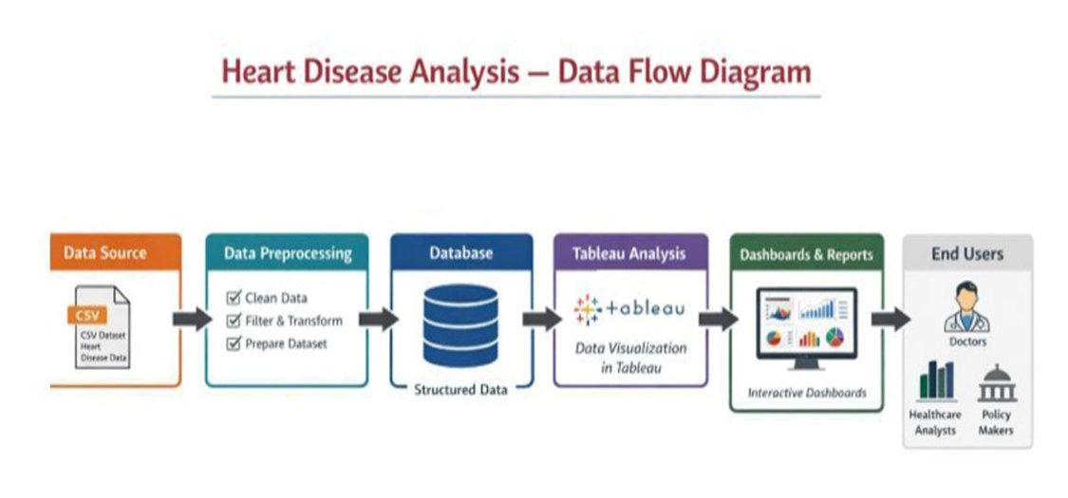

User Stories
Use the below template to list all the user stories for the product.
User Type | Functional Requirement (Epic) | User Story Number | User Story / Task | Acceptance Criteria | Priority | Release
Customer (Web User) | User Access | USN-1 | As a user, I can access the heart disease dashboard through a web browser. | Dashboard loads successfully with visualizations displayed. | High | Sprint-1
 | Dashboard View | USN-2 | As a user, I can view heart disease statistics by age, gender, and lifestyle factors. | Charts display correct data and labels. | High | Sprint-1
 | Filters | USN-3 | As a user, I can apply filters such as age group, gender, smoking, and physical activity. | Visualizations update dynamically based on filters. | High | Sprint-1
 | Comparative Analysis | USN-4 | As a user, I can compare heart disease with diabetes and stroke. | Comparative charts are displayed correctly. | Medium | Sprint-1
 | Story View | USN-5 | As a user, I can view a Tableau story explaining trends and insights. | Story navigation works and insights are readable. | Medium | Sprint-2
Customer (Healthcare Professional) | Risk Analysis | USN-6 | As a doctor, I can identify high-risk patient groups using dashboards. | High-risk patterns are clearly visible. | High | Sprint-1
 | Preventive Insights | USN-7 | As a doctor, I can analyze lifestyle factors contributing to heart disease. | Lifestyle impact charts are accessible and accurate. | High | Sprint-1
Customer (Policy Maker) | Regional Analysis | USN-8 | As a policymaker, I can analyze heart disease trends across different regions or demographics. | Regional comparisons are visible and interpretable. | Medium | Sprint-2
 | Decision Support | USN-9 | As a policymaker, I can use insights to support preventive health policies. | Dashboards provide clear, summarized insights. | Medium | Sprint-2
Administrator | Data Management | USN-10 | As an admin, I can update or refresh the dataset connected to Tableau. | Updated data reflects correctly in dashboards. | High | Sprint-1
 | Performance Monitoring | USN-11 | As an admin, I can monitor dashboard performance and loading time. | Dashboards load within acceptable response time. | Medium | Sprint-2
System | Web Integration | USN-12 | As a system, I can embed Tableau dashboards into a Flask web application. | Dashboard loads successfully inside the web UI. | High | Sprint-1

